***Outreach Notice***

**Shasta-Trinity National Forest**

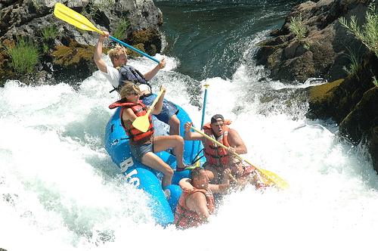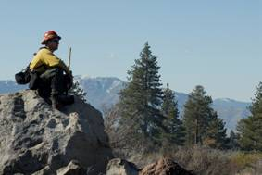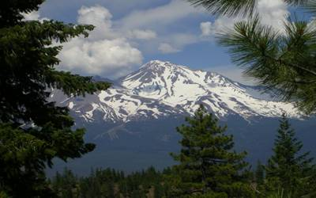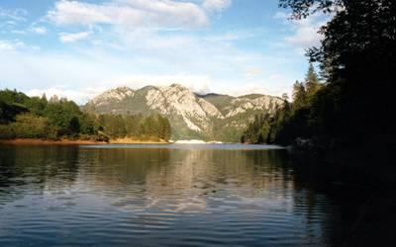

**Join our team on the Shasta-Trinity National Forest!**

**Lead Range and Invasive Species Technician- GS 0404-07 or GS 0455-07**

The Shasta-Trinity National Forest isseeking a dynamic, innovative self starter to work in our Range program as a Lead Ranger and Invasive Species Technician in either the GS-0404-07, Biological Technician series or the GS-0455-07, Range Technician series. Please indicate on your outreach your preference, if any. This position will be a permanent, seasonal position with an 18/2 tour of duty. 18 pay periods (equivalent to 9 months) is guaranteed with potential for year round employment if funding and project work allows. The duty location is Redding, California. If interested in being considered for this opportunity, please send a completed outreach response form to Marilyn Loughrey at mloughrey@fs.fed.us by **January 20, 2012.**

**Duties:**

* Responsible for leading an invasive plant treatment crew that will perform inventory, mapping, treatment, and monitoring of invasive plant populations throughout the Shasta-Trinity National Forest;
* Vegetation monitoring for ecological condition on diverse ecological sites on the Shasta-Trinity;
* Grazing permit administration and grazing allotment compliance monitoring;
* Maintaining fences and livestock water systems;
* Data entry, record keeping, and maintaining databases and geodatabases; and
* Preparing written reports of field activities and monitoring results to support project planning.

**Forest:**

The Shasta-Trinity National Forest, located in north central California, is the largest National Forest in California and provides some of the highest quality fish and wildlife habitat in the Pacific Northwest. It is comprised of 2.1 million acres ranging in elevation from 1,000 feet to 14,162 at the summit of Mt. Shasta. This forest encompasses five wilderness areas, hundreds of mountain lakes and more than 6,000 miles of streams and rivers. In addition, there are wild and scenic rivers, national trails and scenic byways and a National Recreation Area. For further information on the forest, please see **www.fs.usda.gov/stnf**

**Community:**

The Headquarters for the Shasta-Trinity National Forest is located in Redding, California, a full service community of more than 90,000 people. Redding is located along Interstate 5 and has a fine variety of medical facilities, schools including Shasta College, restaurants, retail stores, museums and a variety of housing opportunities. Cultural and outdoor recreational activities include music, art, fishing, rafting, skiing, hiking, sailing, swimming and much more. The climate in the Redding area is generally moderate though summer temperatures can be very hot. Housing is readily available with an average 3-bedroom house selling for about $225,000. Rent for a 2-bedroom apartment ranges from $600 to $1,000 a month, a 3-bedroom house ranges from $800 to $1,450 a month. Government housing is not available.

www.cityofredding.com

http://www.reddinganesthesia.com/redding/

<http://www.redding.com/>

**_____________________________________________________________________**

For any technical questions regarding the above position, please contact:

Philip Brownsey at (530) 226-2432 or by email at pbrownsey@fs.fed.us

For additional information, contact: Marilyn Loughrey, Civil Rights Officer at (530)-226-2367 or by email at [mloughrey@fs.fed.us](mailto:mloughrey@fs.fed.us)